## S.R.S. Recruitment Application

# brought to you by



A project by –

* Siddhant Shinde X A
* Rachietaa Rao X B
* Sanjana Mitra X B

## S.R.S. Recruitment Application

# brought to you by



A project by –

* Rachietaa Rao X B
* Siddhant Shinde X A
* Sanjana Mitra X B

## S.R.S. Recruitment Application

# brought to you by



A project by –

* Sanjana Mitra X B
* Siddhant Shinde X A
* Rachietaa Rao X B

**Index**

|  |  |
| --- | --- |
| **SR.**  **NO.** | **Title** |
| 1. | Title Page |
| 2. | Certificate |
| 3. | Introduction |
| 4. | Critical Analysis of project |
| 5. | Concepts and tools used |
| 6. | Function and Variable Description Table |

**Introduction**

**I] What is this project all about ?**

This Project made using BlueJ Version 4.1.2 of Java is a highly simplified prototype of a Recruitment Software. The project only involves recruitment for engineering candidates. This can be extended to varied fields such as medical, architecture and arts.

The main aim of the project is to find the suitable and ideal company or working place for the user based on both choice and merit. The user can select one of the ten engineering categories namely-

* Agricultural Engineering
* Bio Medical Engineering
* Information and Technology
* Environmental Engineering
* Telecommunications
* Electrical Engineering
* Genetic Engineering
* Mechanical Engineering
* Chemical Engineering
* Aeronautical Engineering

The user can chose from the above branches the branch in which he holds a degree. The user must also mention his/her age which must fit in the ideal age frame (20-55). This feature has been added as per the latest guidelines by companies regarding age of their employees. If the age entered does not fit in the frame, the user cannot proceed.

The percentage of marks scored by the user is also to be entered which is a unique feature of this software. This is done for allotting the user to a company or working place which is inclined towards having employees scoring marks above a certain predefined limit hidden from the user which is ratified by us according to the standard, salary and working condition of employees in the company.

However, choice of the user is also given due respect. Names of three companies are displayed to the user and the user has to rank them in the order of his preference. Accordingly a perfect company is chosen for the user giving him details about it such as – address and approximate package. The user can now go for an interview in the chosen company. A reference card is also provided to the user which can be shown during the interview which must act both recognition and a mark of excellence. An example of its working has been shown below!

**Critical Analysis of project**

During runtime, the following output screen appears. The output screen is embellished with various ASCII coded flowers and designs to make the project more presentable and beautiful. This is followed by a statement which accepts the name.

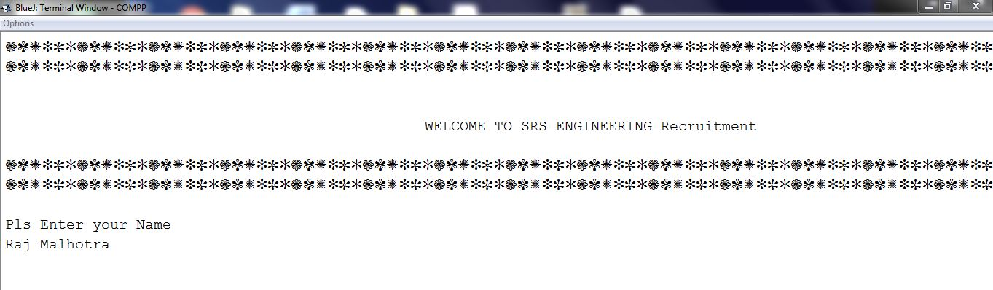

The phone number and age is accepted from the user. The statement System.out.err is used to provide a note to the user regarding the ideal age group and the requirement of the companies.

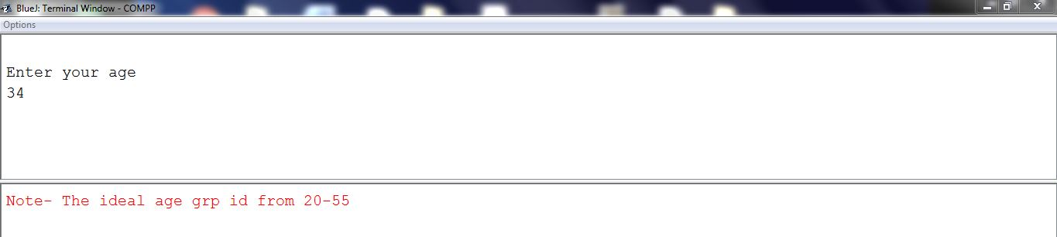

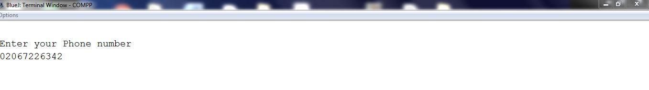

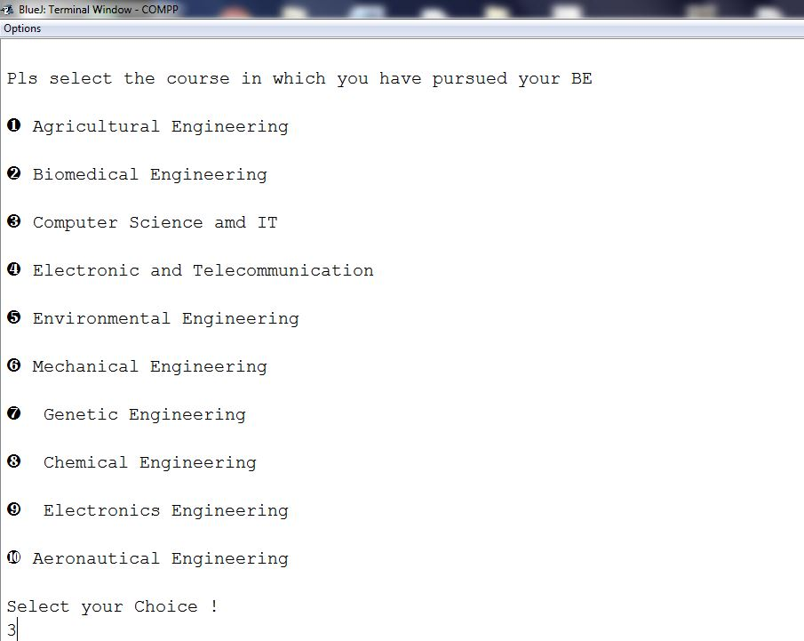

The user can chose from the above categories, the categories in which he holds a degree. After this categories of the stream are entered, the user selects the desired branch. After this, names of companies are displayed and then the user is asked for his preference. However the system selects a perfect company based on both merit and choice.

The preference mechanism has been designed in a way such that due respect is given to both merit and choice.

This works in the following way –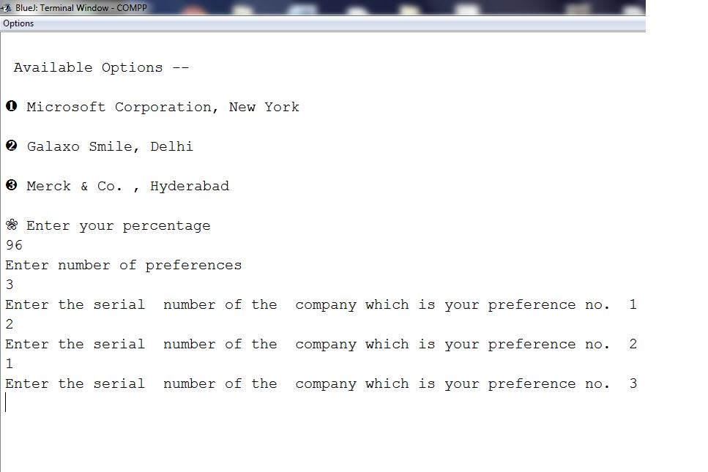

Here, the first company mentioned is the best one and requires a very high percentile score and the MPR for the others follows in the descending order. In the above example, the user has secured 96 %, hence he is eligible to enter any of the above companies irrespective of the minimum percentage requirement (MPR). However, the user has selected the second company as his first preference, hence he would get the second company (Galaxo Smile) though he is eligible for the first company. Hence both choice and merit are taken into consideration. This is the image of the message displayed and reference card respectively.

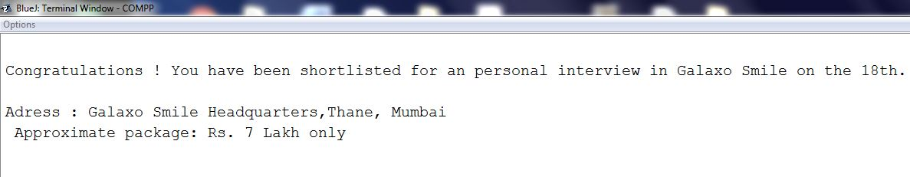

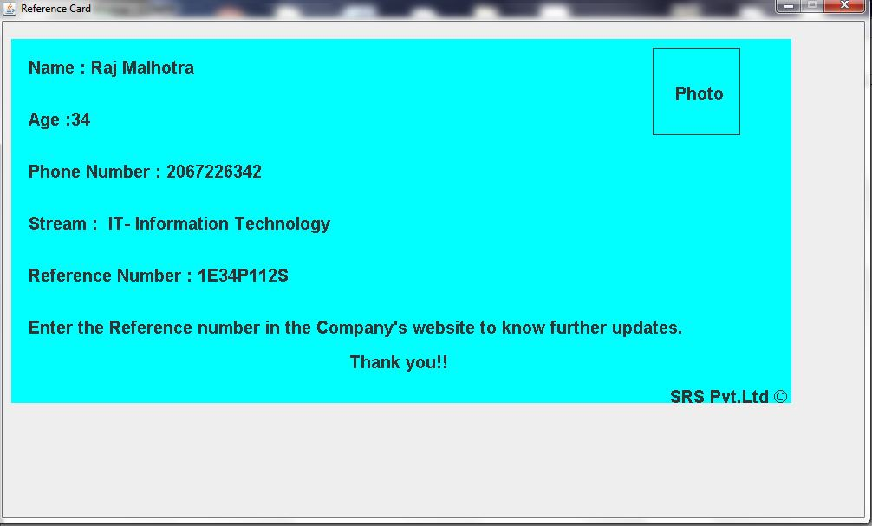Let’s consider a case, where the user enters 75 % as his score and selects the 1st company as his first preference and the third company as his second preference. In this case, the user is not eligible for his first preference, he is eligible for the second company, however it his last preference and so the third company is chosen. The above case is shown below.

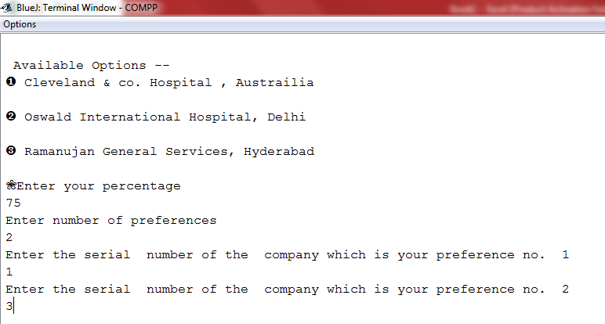

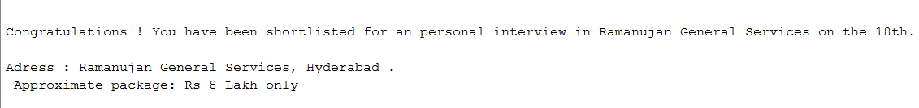

**Concepts**

**1**] **InputStreamReader and BufferedReader:-**

The CPU/processor is the fastest device in computer. Other peripheral devices are comparatively slower than processor. Due to speed differences it becomes difficult to have data communications between the processor and peripheral devices. Hence, high speed memory is applied between I/O devices and the processor and is used as a bridge to synchronise their speeds. This high speed temporary storage (also called as CACHE memory) is termed as Buffer. You need to activate Buffer before any input or output operation.

BufferedReader reads a couple of characters from the specified stream and stores it in a buffer. This makes input faster.

InputStreamReader reads only one character from specified stream and remaining characters still remain in the stream.

When one or more Threads or objects want to read characters from [System.in](http://system.in/) then in that case InputStreamReader should be used because it reads only one character and remaining can be used by other objects or threads.

BufferedReader is fast because it maintains a buffer and retrieving data from buffer is always fast as compared to retrieving data from disk/stdin (Standard Input).

InputStreamReader class can be used to read data from keyboard. It performs two tasks:

* connects to input stream of keyboard
* converts the byte-oriented stream into character-oriented stream

BufferedReader class can be used to read data line by line by readLine() method.

The statement **“throws IOException**” eliminates I/O errors in the program (if any), it passes the reports on I/O errors to the exception handler of Java System.

**2] if Construct:-**

If statement is used to check a specified condition. It performs a certain course of action if the condition is true otherwise, the condition is ignored. If the given condition is true, the statements are executed if the condition is false the control ignores the statements and passes to the next line of the program.

If and only if statement is used in logical situations where different tasks are to be performed selectively by applying various conditions. In case the condition is false, then the control ignores execution of its adjoining statements and moves to check the next condition.

If else, is a logical situation when either of the 2 actions is to be performed depending upon a certain condition. If the condition is true, it performs one set of statements, otherwise, it performs another set of statements.

If - else if a logical situation when more than 2 action are to be performed depending upon the condition. It is performed with the keyword ‘else if’. When the condition is true, it performs one set of statement, if the condition is false, then the control enters the “else if” part and checks second condition. If it is true, then it performs the task of second statement otherwise it executes the third statement.

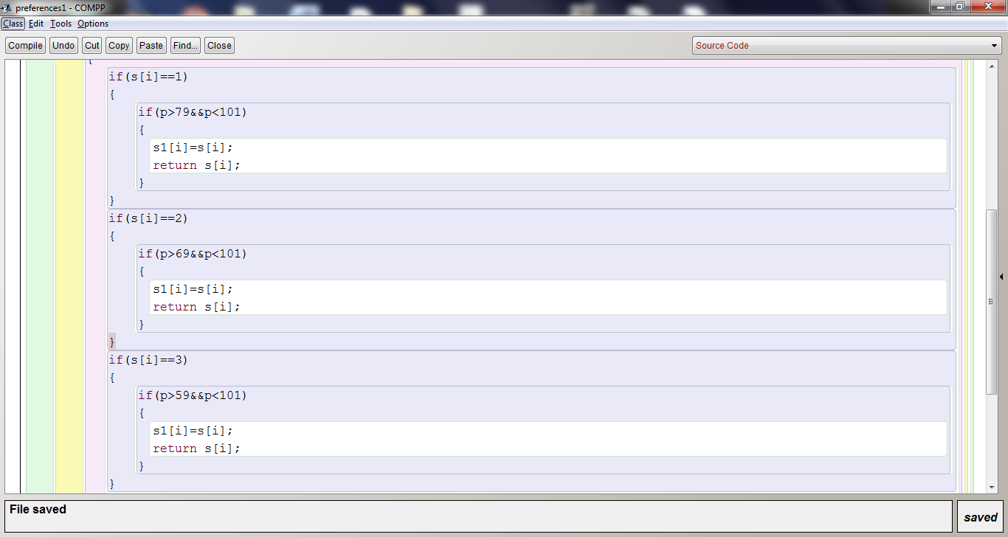

**In our project, we’ve used If Construct numerous times in the preference mechanism and also while selecting the stream of engineering.**

**3] Switch Case statement/Menu Driven/ User’s Choice:-**

Switch Case is a multiple branching statement in which the control may transfer to a specific case to perform the defined job based on the given value of the switch variable.

The variable used in brackets in a switch case statement is called the switch variable or control variable. The value of this variable determines which case of the switch block will be executed.

In order to avoid execution of all cases that follow the desired case **break** statement is used to shift the control out of the switch block after the compilation of the particular case.

If no case is available for the given value of switch variable, the **default** case is used. The default case is even used to display a message for the user indicating that he has obtained for the wrong choice.

In a program where multiple cases are available, the control needs to execute specific case block for a given switch value. If the break statement is not applied at the end of a case then the control enters into the next case statement for execution. This unusual execution of one or more than one case at a time is termed ‘**fall through’**.

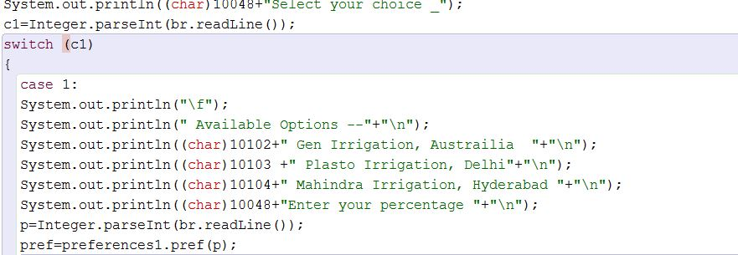

**In our project we’ve used it in accepting the choice of the user.**

**4] For Loop:-**

We can perform any conditional repetitive type of flow very easily with the help of a for loop. A for statement is used for a fixed number of iterations. The for loop will be executed for all values of the control variable from initial value to the final value, with the increment/decrement of the step value.

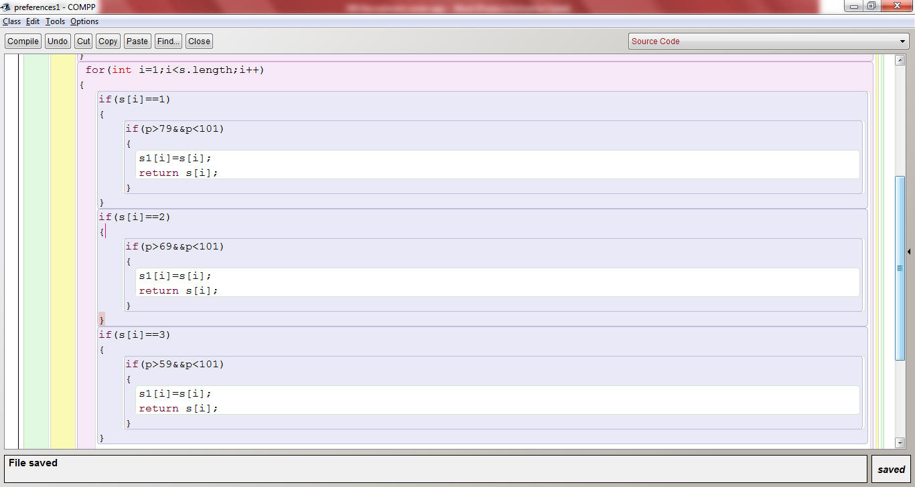

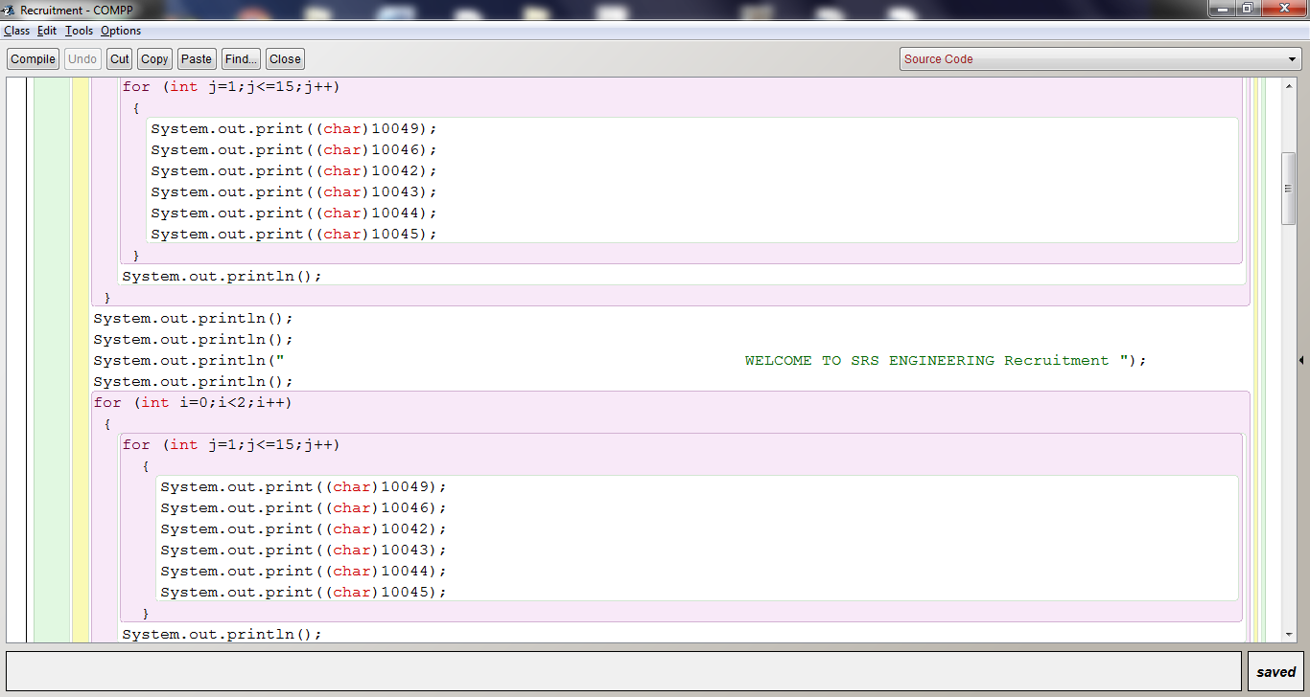

**We’ve used For Loop for both computation (Fig 1) and for the embellishments (Fig 2) on the output screen. It can also be used to input data in case of arrays.**

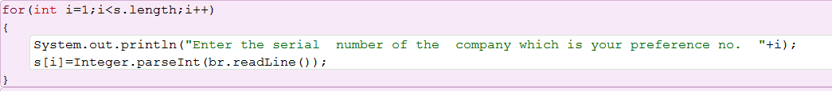

**5) Functions –**

**A function or method is a programme module, which is a part of the programme used simultaneously at different instances in a programme to perform a specific task. Syntax of a declaring a function –**

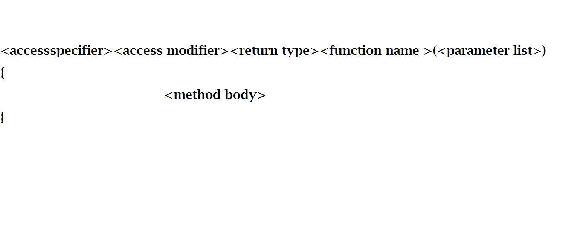

**We have used functions many times in our project to make the computation much easier.**

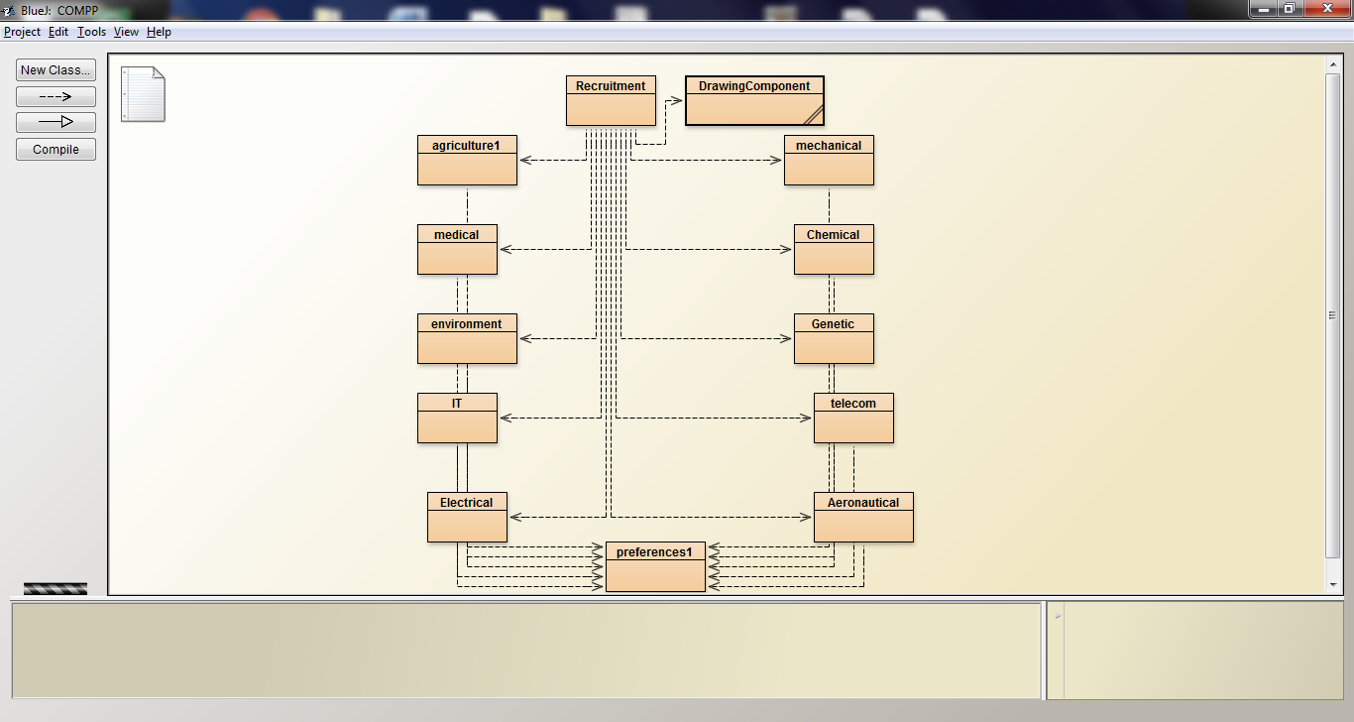

**This is a picture of the project, which consist of varied classes each one of them containing a function. All the functions are called by main method in class recruitment.**

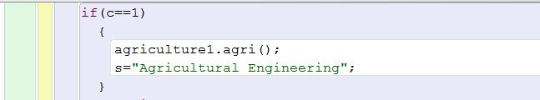

**Here, the function agriculture1 is called from class agri.**

**6) Arrays –** A dimensional array is a structure created in the memory to represent a number of values of same data type with varied subscript. We’ve used arrays for the preference mechanism.

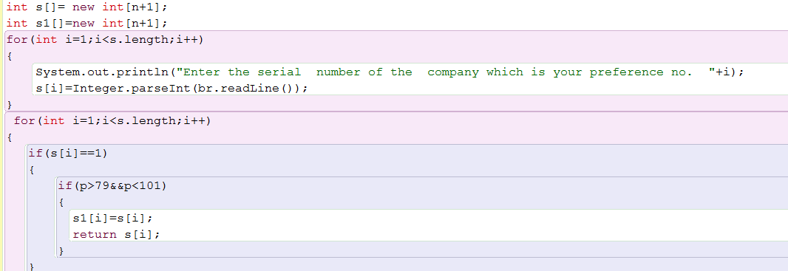

**Tools used**

**1]** **Java.io.* package**:

Java I/O (Input and output) is used to process the input and produce the output

It consists of 3 Streams:

* System.in : Standard input stream
* int i=System.in.read();
* System.out : Standard output Stream
* System.out.println(“Simple message”);
* System.err : Standard error stream
* System.err.println(“Error Message”);

**2] Javax.swing.* package**:

It is used to create window-based applications. It provides light weight components and is platform-independent.

The packages under javax.swing which we have used are:

* **JFrame**: It inherits the java.awt.Frame class. JFrame works like the main window where components like labels, buttons, textfields are used to create GUI (Graphics User Interface).JFrame also has the option to hide or close the window with the help of setDefaultCloseOperation (int) method.
* **JComponent**: It is a container class that extends the component class. The class provides layout hints and supports painting and events and many more.
* **JPanel**: It is a container class that provides space in which an application can attach any other component. It inherits the JComponent class.

The main task of JPanel is to organize components, various layouts can be set in JPanel which provides better organization in the components.

**Note**: J is a text editor in Java, thus we use J in front of super classes like Frame, Component and Panel. ‘X’ is used in javax.swing because it is an extension package and not a core package. An example of core package is java.io.*.

Since JPanel inherits JComponent class by providing space for the components, it is declared while assigning the name of the class.

Eg: public class Recruitment extends JComponent

‘Extends’ Keyword is used to inherit the properties of the super class.

**3] Content Pane**:

Content Pane holds the components. The components are sized and positioned by the Layout Manager when JFrame Packages are formed. It is a variable received from class JFrame

**4] java.awt.* package:**

* **java.awt.graphics package**: The graphics class is the abstract super class for all graphics contexts which allow an application to draw onto components that can be realized on various devices, or onto off-screen image as well. A Graphic object encapsulates all state information required for the basic rendering operations that Java supports.
* 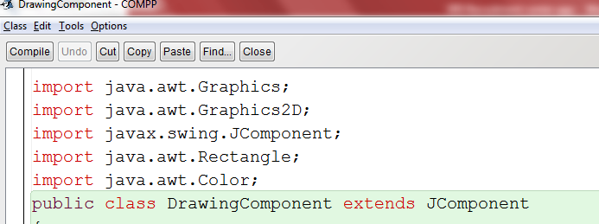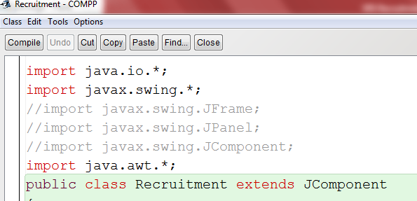**Java.awt.Graphics 2D**: This is the fundamental class for 2D rendering in Java .This class extends the original java.awt.Graphics class to provide more sophisticated control over geometrty, coordinate transformation , color management and text Layout. Given below is an example of the packages used in the project in class Recruitment (left).

These are the packages used to create the Reference card at the end of the program in class Drawing Component (right). Java.awt.Rectangle and Java.awt.Color are the packages which fall under java.awt.* package. Rectangle is the superclass that creates space for a rectangle in the content pane and color is the superclass to add color to the content pane or the rectangle in the case of the reference card.

VARIABLE DESCRIPTION TABLE

|  |  |  |  |
| --- | --- | --- | --- |
| **SR**  **NO**. | **VARIABLE**  **NAME** | **DATA TYPE** | **DESCRIPTION** |
| **1.** | age | static int | age of the user |
| **2.** | c | static int | Enter choices for category of Engineering |
| **3.** | c1 | static int | Enter choices for branches of Engineering |
| **4.** | phone_n | static long | For accepting phone name |
| **5.** | name | Static String | For accepting the name of the user |
| **6.** | p | Static double | For accepting the percentage of the user |
| **7.** | s | Static String | Stream given after the programme is executed for the reference card |
| **8.** | cnt | Static int | To terminate the program if the age is invalid |
| **9.** | pref | int | Counter for preferences |
| **10.** | n | int | No. of preferences |
| **11.** | S[] | String array | Array while entering preferences |
| **12.** | s1[] | String array | Array after preferences has been executed |